OOPs concept : Object Oriented Programming

Object : object is any real world entity.

Property or state ---🡪 have 🡪 pid, pname, age, phonenumber etc.

Person

Behaviour -🡪 do/does -🡪 action -🡪 teaching(), listening(), sleeping() etc

Bank

Manager

Car

Customer

Object is a concept etc.

function or class

class : blue print of object or template of object or user defined data type which help to create the object.

In JavaScript till ES5 to create user defined object we are/were using function.

Function style object creation.

From ES6 onward we are using class concept to create the object.

Class style object creation.

In JavaScript object are divided into 2 types.

Pre defined object

JavaScript provided two pre defined object hierarchy.

BOM : Browser Object Model

DOM : Document Object Model

Object -🡪 property or state or variable

Behaviour or function

Object ------------🡪 Property

Behaviour

Object -----------🡪 property

Behaviour

Object

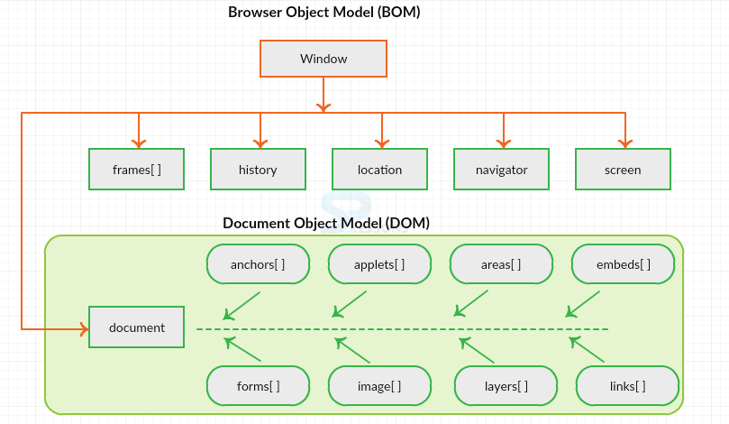

document.write(“Welcome”);

document is a pre defined object and write a d pre defined object.

objectname.functionName(); to access that function()

objectname.propertyname to access the property value

index.html once we run any web page in browser

internally it will create DOM Hierarchy.

Html

Head body

Title div Welcome

Style p

Script

Meta

DOM Parser : lot of programming language like Java, python, C++ or JavaScript provided

Function or methods which help to read, write and update html contents or dom contents dynamically.

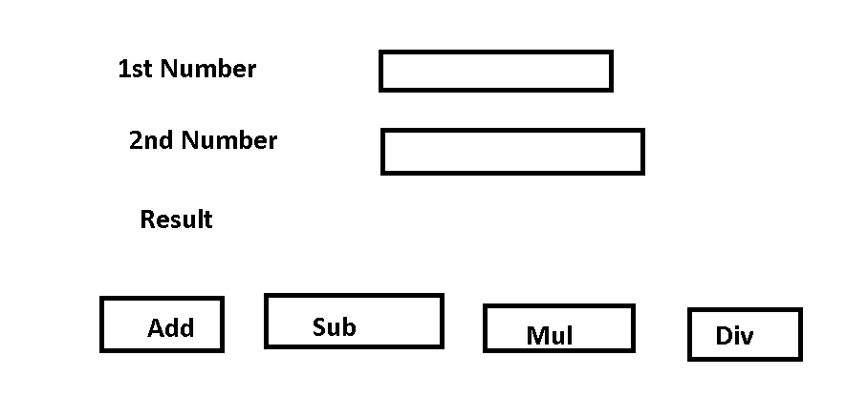

User defined object

Synchronization

ASynchronization

Statement Level Synch one by one.

document.write(“1st Statement”);

document.write(“2nd Statement”);

document.write(“3rd Statement”);

Statement Level ASynch

document.write(“1st Statement”); sync

document.write(“2nd Statement”); ASynch

document.write(“3rd Statement”); Asycn

if statement is asych that statement execute independently

Function level synch

fun1()

fun2()

fun3();

Function level asynch

fun1()

fun2() asyn

fun3();

Client and Server Communication level

Sych

1st

2nd

3rd

Client Server

ASych

1st

2nd

3rd

Client Server

AJAX : Asynchronous JavaScript and XML

In JavaScript if we want to create custom asynchronous operation we can use 3 pre defined functions

Ie

setTimeout : it will execute only one after specific time.

setInterval() : it will execute again and again after specific time.

clearInterval()